 **2400 N. 32nd St**

**TENKILLER Muskogee, OK 74401**

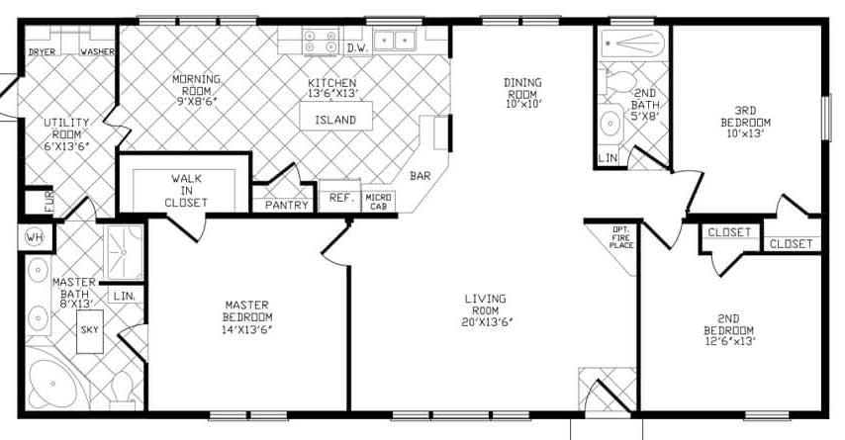**28X60 1568 SQ. FT 3BED/2BATH 918-683-7791 www.homestoreltd.com**